Accident at Home Form

If your child has an existing injury from home please could you make us aware of what the injury is and how it happened by completing this form.

It is important that we know this information to help protect children, understand when and where an accident has happened in order to help us reduce the risks of accidents within our setting and to help us support the child if they have an injury that may affect how they are feeling.

Name of Child:
Today’s Date:
Time and date of when accident happened:
Area where accident happened:

Description of accident and injury (include details such as bruise colour):

Where is the injury:
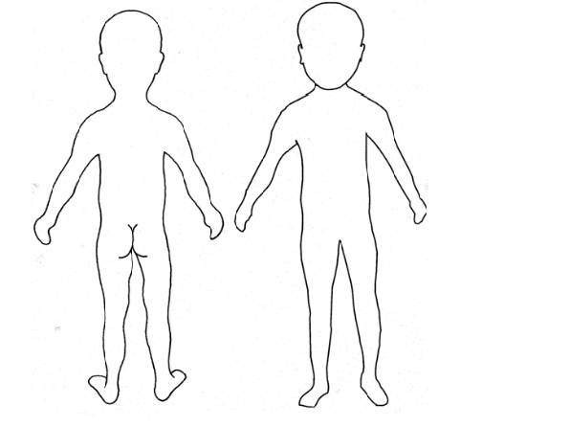

Treatment Details:

Emergency services contacted? YES NO

If yes, what advice or treatment was recommended?

Parent Name: Signature:

