Year 5 Curriculum Newsletter – Autumn 2 Term 2025
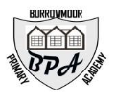
Dear Parents and Carers,
Welcome back to a new school year! We hope you have all had a fun-filled half-term. Please find below a summary of Year 6’s main learning areas for this term along with some general reminders.

📚 English Writing
Our writing this term is inspired by The Barnabus Project by The Fan Brothers, a story about Barnabus, a half-mouse, half-elephant creature who dreams of freedom. We will write descriptive settings and character descriptions, create a non-chronological report about their own hybrid creature, write instructions for “The Great Escape,” and finish by planning and writing an original story featuring the invented character.

📖 Reading
In Reading, we will continue exploring The Nowhere Emporium by Ross MacKenzie, a magical adventure about a shop filled with wonders and secrets. We will develop fluency and understanding by learning unfamiliar words, summarising what we have read, and retrieving answers to questions.

➗ Maths
During this half term, we will start by learning about positive and negative numbers, then move on to multiplication by partitioning (leading to short multiplication with 2-digit and 3-digit numbers), division by partitioning (leading to short division), and finally explore the concept of area.

Science
This term, we will be building on their knowledge of materials. We will investigate the properties and uses of different materials, including solids, liquids, and gases, and consider how these properties make them suitable for specific purposes. We will revisit experiments involving separating mixtures, changing states, and exploring reversible and irreversible changes. Through hands-on activities and practical investigations, we will develop our scientific enquiry skills and deepen our understanding of how materials behave in the world around them.

P.E.
Year 5 will have PE on a Wednesday (Indoors), and outdoor PE on Friday so please ensure your child always has their PE kit in school and are prepared for the unpredictable winter weather. PE kit is a plain white t-shirt or polo shirt, black or navy shorts, black or navy tracksuit bottoms and an outdoor jumper (when the weather requires it), outdoor trainers (these must be different shoes to the ones your child wears to school) and a water bottle. Indoor PE will take place on Thursday and will be gymnastics for this term.

Homework
Spellings we will upload the words that we are focussing on weekly to dojo for you to look at and practise with your child. Please note there will be no formal spelling test as we will be assessing through application of rules in lessons.

For Maths homework, the children need to complete 15 minutes TT rock stars (https://ttrockstars.com/) each week. In addition, children are required to practise multiplication tables and division facts to aid rapid recall. Every week there will be an informal check as part of the maths lesson.

Furthermore, we ask that the children read at least 3 times a week at home. When your child has read, could you complete their reading record by writing a comment in their book and sign it too. This will really help them to progress in reading and writing. We will be checking your child’s reading diary regularly throughout the week. The children will then quiz on AR (accelerated reader) where we can track their comprehension progress.

🌍 Foundation Subjects
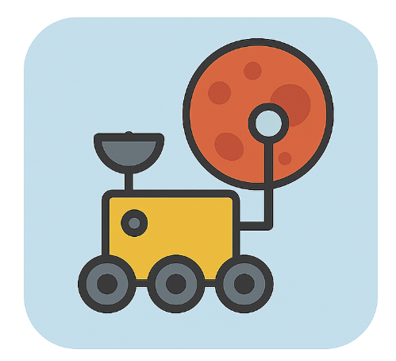 |  | 
Computing – Mars Rover: Children will explore how data is collected and transmitted from space, learn about binary code, and understand how computers process information. | Geography – Spatial Sense: Children will develop map skills, use coordinates, and understand global features like time zones and climate zones. | DT – Cam Toys:  Children will design and build a moving toy using a cam mechanism, learning how cams and followers create movement.
 |  | 
Music – Blues:  Children will learn about the history of Blues music, play the 12-bar Blues, improvise using the Blues scale, and compose their own piece. | PSHE – Health and Well-being: Children will learn about healthy lifestyles, including relaxation, sleep, sun safety, and balanced eating, while developing resilience and managing emotions. | Spanish:  Children will learn beginner vocabulary and phrases to talk about numbers, dates and birthdays, family members, pets, sports and hobbies, school subjects, and the weather.
 | 
Religion & Worldviews:  In the Religion and Worldviews unit “Why are some places in the world significant to believers?” children will explore why places like Jerusalem, the Golden Temple, and the River Ganges are special to different religions and what makes places sacred. | Indoor PE:  Children will practise throwing, catching, and dodging skills, learn simple tactics for attacking and defending, and work as a team while playing fun, safe dodgeball games.

If you have any questions, please speak to your child’s class teacher. For any additional information, please refer to Class Dojo.

We are looking forward to an exciting term ahead, thank you in advance for your continued support.
Miss Watson and Mr Hughes

