Welcome to
Burrowmoor Primary Academy’s
Easter Service 2026
with Years 5 & 6
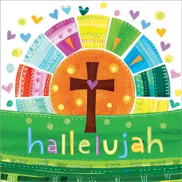
Friday 27th March
11 am
St Peter’s Church

Welcome from Mrs Ruth Bailey

The Story of Easter – readings by Year 5 pupils

Sing Hosanna

The Story of Easter – readings by Year 5 pupils

Here he stands

The Story of Easter – readings by Year 5 pupils

The Lord of the Dance

Blessing from Rev’d Andrew Smith

You are my brother

